CHEMICAL ENGINEERING TRANSACTIONS  VOL. , 2023 | A publication of
The Italian Association
of Chemical Engineering
Online at www.cetjournal.it

Guest Editors: Leonardo Tognotti, Rubens Maciel Filho, Viatcheslav Kafarov
Copyright © 2024, AIDIC Servizi S.r.l.
ISBN 979-12-81206-10-1; ISSN 2283-9216

Black Liquor Gasification in Supercritical Water: Thermodynamic Study for Isothermal Systems
Julles Mitoura dos Santos Juniorª, Annamaria Dória Vidotti^{b}, Antônio Carlos Daltro de Freitas^{b}, Reginaldo Guirardello^{a*}
ªSchool of Chemical Engineering, University of Campinas, Av. Albert Einstein 500, Campinas-SP, 13083-852, Brazil
^{b} Chemical Engineering Department, Exact Sciences and Technology Center, Federal University of Maranhão - UFMA, Av. dos Portugueses, 1966, Bacanga, São Luís-MA, 65080-805, Brazil
guira@feq.unicamp.br
From the pulp and paper industry, black liquor is a process byproduct obtained from the digester discharge and is primarily composed of lignin, hemicellulose, cellulose residues, and water. Managing this byproduct is a critical aspect of the industry, and typically, this byproduct is destined for controlled disposal after treatment. As an alternative to using this byproduct for the generation of high-value-added products, the process of supercritical water gasification presents itself as a promising technology, enabling the conversion of black liquor into a stream of products predominantly composed of hydrogen. This work focuses on the thermodynamic study of the black liquor gasification process in supercritical water. To solve the combined phase and equilibrium problem, methodologies involving Gibbs energy minimization will be employed, formulated in the context of nonlinear programming simulating operational conditions of isothermal reactors. The optimization tool used is the GAMS® software version 23.9.5 with the assistance of the CONOPT4 solver. Initially, validation of the results obtained by the proposed modeling was performed against previously reported literature data, yielding satisfactory results with average relative errors less than 2.65% and 6.33% for H₂ and CO₂ formations, respectively. Thermodynamic approach results indicate that temperature increases tend to maximize hydrogen formation, an expected outcome considering that reactions with higher hydrogen formation indices are endothermic. In contrast to the temperature effect on hydrogen formation, increases in pressure and the amounts of black liquor in the process feed tend to minimize hydrogen formation. This can be justified by the fact that pressure increases disfavor product formation according to Le Chatelier's principle, and the increase in black liquor in the process feed implies lower black liquor/water ratios, thus unfavoring water displacement reactions and reducing hydrogen formation. In summary, higher hydrogen formation rates (67.33%) are achieved at elevated temperatures (800 °C), low pressures (220 bar), and low concentrations of black liquor in the process feed (0.60% wt), indicating a strong demand for water in facilitating this process when characterized for hydrogen formation.
  - Introduction
The expected increase in energy consumption is directly related to the increase in pollutant emissions given that the global energy matrix is ​​heavily dependent on fossil fuels. Within the context of energy sources with low environmental impact, hydrogen stands out due to its high energy density and the fact that it generates only water during its combustion. Hydrogen provides up to three times more energy (39.4 kWh/kg) when compared to fuels based on fossil sources (13.1 kWh/kg) during combustion (Züttel, 2004).
Hydrogen can be produced through different routes, through fossil fuels (coal and natural gas) without or with carbon capture, and through the electrolysis process (integrated with renewable energies such as solar and/or wind), being classified as hydrogen gray, blue and green, respectively. Other possible paths are associated with thermochemical routes combined with biomass processing (Karaca et al., 2023).
Supercritical water gasification (SCWG) routes have been highlighted among the possible routes for producing hydrogen from biomass, the gasification reaction in supercritical water has been playing a prominent role, mainly because the high hydrogen amount produced during reaction (Ciuffi et al., 2020). The supercritical water gasification route (SCWG) can be used for processing different types of biomass materials (Freitas and Guirardello, 2013). An alternative is to use by-products from other processes as a substrate for the SCWG process to produce hydrogen, as initially presented by Barros et al. (2022).
Within this context, the focus of this article is to thermodynamically analyze the black liquor SCWG process aiming for hydrogen production. To achieve this, the Gibbs energy minimization methodology will be applied to represent the operation representing isothermal reactors. The results obtained will enable a better understanding of the use of the SCWG route for the thermochemical valuation of black liquor to produce green hydrogen from an important residue from the paper and cellulose industry.
  - Methodology
2.1. Modelling isothermal reactors: Gibbs energy minimization model
Under conditions of constant pressure (P) and temperature (T), the condition of thermodynamic equilibrium can be formulated as a problem of minimizing Gibbs energy (Gomes et al., 2022). The total Gibbs minimization problem of the system can be described according to Equation 1.

$$\min{G} = \sum_{i=1}^{NC}{\sum_{k=1}^{NF}{n_{i}^{k}}∙\left[μ_{i}^{o}+RTln\left({{\hat{f}}_{i}^{k}}/{f_{i}^{o}}\right)\right]}$$ | (1)
The system in the condition of Gibbs minimum energy must satisfy the condition of non-negativity of the number of moles and the conservation of the number of atoms (Eq. 2).

$$\sum_{i=1}^{NC}{\sum_{k=1}^{NF}{\left.{a_{mi}∙\left(n\right.}_{i}^{k}\right)}}= \sum_{i=1}^{NC}{\left.{a_{mi}∙\left(n\right.}_{i}^{0}\right), } { n}_{i}^{k} ≥0$$ | (2)

To simplify the thermodynamic modeling of the process, the solid phase was treated as ideal, eliminating the need to estimate non-idealities for this phase.
For the prediction of fugacity coefficients in reaction systems under supercritical conditions, equations of state (EoS) must be carefully selected. There are reports of successful applications of Peng-Robinson (PR) and Peng-Robinson Boston Mathias (PR-BM) EoS in the study of supercritical biomass-in-water gasification reaction systems (Hantoko et al., 2019). For this study, the PR EoS (Eq. 3) was applied to calculate the fugacity coefficients of the verified system. Simplified mixing rules were used as reported by Downling et al. (2015).
$$\ln{\hat{∅_{i}}}{=\frac{B_{i}}{B}\left(Z-1\right)-\ln\left(Z-B\right)+\frac{A}{2\sqrt{2}B}\left(\frac{B_{i}}{B}-2\frac{\sum_{j}{y_{i}\sqrt{a_{i}a_{j}}}}{a_{m}}\right)\ln\left(\frac{z+(1+\sqrt{2})B}{z+(1-\sqrt{2})B}\right)}$$ | (3)
The thermodynamic models in this work will be solved by the GRG (Generalized Reduced Gradient) search method, using the CONOPT4 solver, in the GAMS software. The microalgae black liquor was written as a pseudocomponent (C₆H₁₀O₆). Throughout the simulations, formations of 15 possible components were taken, these are: C₃H₈O₃, O₂, H₂, N₂, CH₂O₂, H₂O, CH₃COOH, CH₄, CH₃OH, C₂H₆, C₂H₆O, C₃H₈, C₄H₁₀, CO and CO₂. This selection is based on findings from the literature, indicating that these components are frequently observed in significant proportions during gasification processes involving biomass from various sources (Gomes et al., 2022, Mitoura et al., 2021 and Yan et al., 2006) all thermodynamic properties are obtained from literature (Poling et al., 2001). The black liquor SCWG will be verified with the aim of maximizing hydrogen formation throughout the process. The profiles of carbon monoxide, carbon dioxide and methane formation throughout the process will also be studied.
2.2. Statistical analysis
The statistical treatment was applied in order to evaluate the effects of temperature, pressure and composition of the biomass feed on the reaction behavior, a Central Compound Experimental Design (DOE) was developed in order to verify 3 factors, 1 central point for each factor, using 16 runs. This type of design is often used to determine the influence of independent factors in a process and to optimize experimental conditions due to the existence of axial points (Agresti, 2012). Table 1 presents the independent variables, the coded and real values ​​of the variables considered during performed simulations.
Table 1: Absolute and coded values ​​for pressure, temperature, and biomass composition in the process feed.
 | Temperature (K) |  |  | Pressure (bar) |  |  | Biomass (%wt)
Coded Values | -1 | 0 | 1 | -1 | 0 | 1 | -1 | 0 | 1
Real Values | 723.15 | 973.15 | 1223.15 | 200.00 | 250.00 | 300.00 | 2.00 | 37.00 | 72.00
  - Results and discussion
3.1. Methodology validation
To validate the methodology for predicting the values of equilibrium compositions, the SCWG process was considered, based on the experiments performed by Barros et al. (2022) where this process was performed in a continuous flow reactor (Length: 0.373 m, Internal Diameter: 0.013 m) built from Inconel 625 - which is a Ni-Cr-Mo superalloy with high resistance to oxidation and corrosion at high temperatures, preheater, condenser, phase separator and pipes made of 316 stainless steel. Table 2 presents a comparison between the experimental results reported in Barros et al. (2022) at 230 bar and the results obtained using the Gibbs energy minimization methodology associated with the Peng-Robinson equation calculated by this paper.
Table 2: Validation of the methodology with experimental data reported by Barros et al. (2022).
 |  | H₂ (% mol) |  | CH₄ (% mol) |  | CO (% mol) |  | CO₂ (% mol)
Feed Concentration (% wt) | Temperature (K) | Sim. | Exp. | Sim. | Exp. | Sim. | Exp. | Sim. | Exp.
0.10 | 773.15 | 65.08 | 64.41 | 2.26 | 4.01 | 0.00 | n.d. | 32.40 | 31.34
2.55 | 698.15 | 69.23 | 69.04 | 29.82 | 28.75 | 0.03 | n.d. | 36.65 | n.d.
5.00 | 773.15 | 52.44 | 53.35 | 8.15 | 7.57 | 0.13 | n.d. | 35.34 | 38.77
n.d.: Not detected Sim.: Simulated value Exp.: Experimental data
The results presented in Table 2 indicate that the simulations present excellent fits with the experimental data with coefficients of determination equal to 0.998 and 0.997 for the molar fractions of hydrogen (H₂) and methane (CH₄), respectively. Considering that the model presented a good fit to the experimental data, the following topic presents predictive results for the behavior of the black liquor SCWG process under different operating conditions, considering isothermal reactors.
3.2. Study of process conditioned in isothermal reactors
Given the operating conditions presented in Table 1, Figure 1 shows the formation of H₂ as a function of temperature and biomass % weight, for two different pressure conditions (200 bar and 300 bar). The effect of biomass % weight on the behavior of the reaction process is presented, where the feed for the process is composed only of biomass and water (2 moles). This consideration is adopted for other results in this work.
The results in Figure 1 indicate that hydrogen formation is maximized with increases in temperature and biomass in the process feed. This result is expected according to the kinetic models reported by Jin et al. (2015) and Guo et al. (2006) due to the fact that gasification reactions are endothermic and are therefore optimized with increases in temperature. However, pressure increases tend to minimize hydrogen formation. This result is predicted by the model of Guo et al. (2006), where it is described that increasing pressure disfavors the formation of products of interest during the process. This is justified by the fact that the increase in pressure disfavors the water-gas displacement reactions and the methanation reaction is favored, in accordance with Le Chatelier's principle, thus, hydrogen is largely consumed, forming methane (CH₄) and carbon dioxide (CO₂).
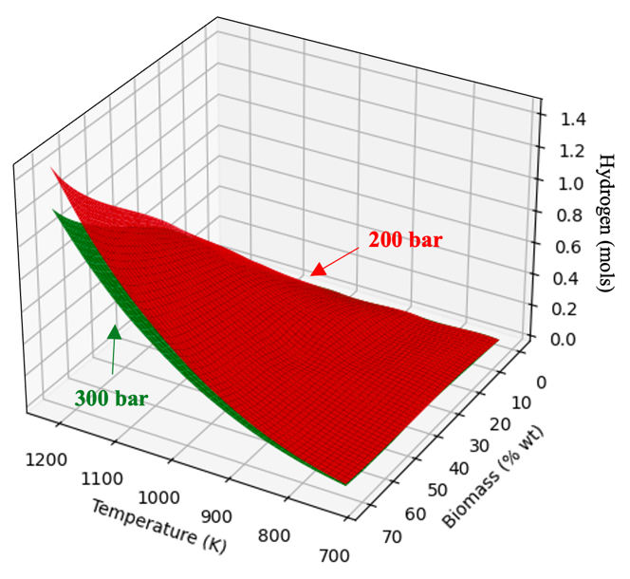
Figure 1: Hydrogen formation as a function of temperature and biomass composition under fixed pressure conditions.
To better verify the correlations between the variables of interest, Figure 2 presents a Spearman correlation matrix. From the results presented in Figure 2, it is clear that both variables have a low correlation with pressure variation, which may indicate that this variable has little influence on the formation of other products throughout the process. Similar results for the pressure effect are reported in the literature for systems that use supercritical water processes, as in Dias et al. (2024) when studying the treatment of pharmaceutical waste in supercritical water.
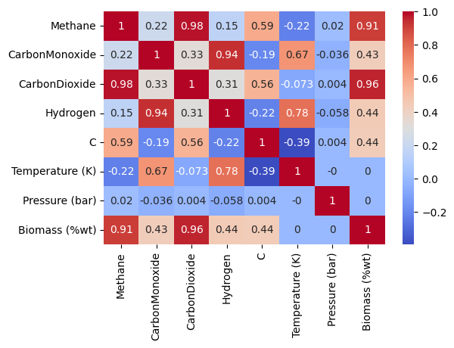
Figure 2: Spearman correlations for black liquor SCWG process variables.

Regarding products formed in larger quantities, the formation of hydrogen and carbon monoxide present positive correlations with temperature and the mass percentage of biomass in the process feed. The formation of methane has a negative correlation with temperature due to the fact that methanation reactions are predominantly exothermic and the behavior of the formation of this product is similar to the formation of carbon dioxide. In addition to these, a small formation of solid carbon was noticed throughout the process (< 0.11 mols) which is maximized with decreases in temperature and increases in biomass in the process feed.
Figure 3 shows the effect of pressure on the formation of products throughout the process and in fact it can be seen that pressure has little influence on the formation of products, however, increases in pressure tend to minimize the formation of hydrogen and carbon monoxide.
As previously verified, increases in biomass in the process feed tend to maximize the formation of hydrogen, however, the increase in biomass also favors the formation of other products and for this reason, although the formation of hydrogen is increased, its molar fraction tends to decrease.

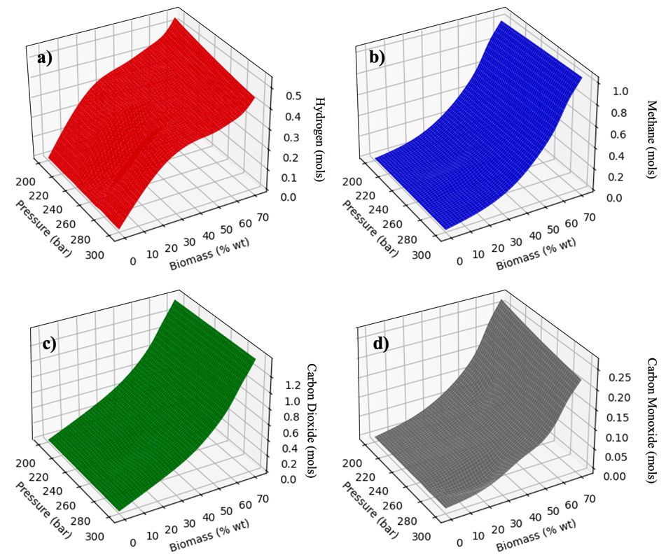
Figure 3: Formation of majority products as a function of pressure and biomass composition at 1000 K (a: hydrogen; b: methane; c: carbon dioxide; d: carbon monoxide).
Figure 4 shows the formation of products as a function of temperature at constant pressure of 260 bar under fixed conditions of biomass composition in the feed.

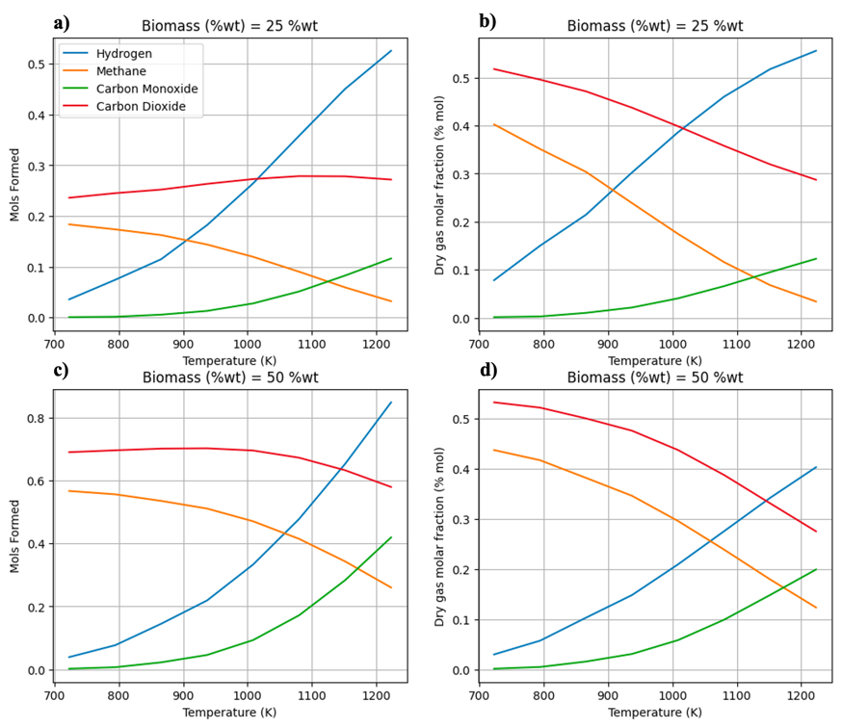
Figure 4: Formation of the majority components (mols) and molar fraction as a function of temperature under fixed biomass compositions in the process feed at 260 bar (a and b: 25 %wt; c and d: 50 %wt).

Figures 4a and 4b show the formation of products and the molar fraction of products as a function of temperature with biomass composition in the feed set at 25% wt. It can be seen that in fact the molar quantities of hydrogen tend to be maximized with increases in temperature as well as the molar fraction of this product. However, when looking at the results in Figures 4c and 4c where the biomass composition in the process feed was increased to 50% wt, it is clear that the molar fraction of hydrogen was minimized and the molar fraction of the other products increased. Another important result to be emphasized is the decrease in the presence of methane in the system as we increase the process operating temperature. This behavior is inverted with the formation of hydrogen in the system, emphasizing the association of these two components to the reaction network that represents this reaction system. This behavior was observed within the entire range of feed compositions studied for the black liquor SCWG reaction.
Thus, the increase in biomass in the feed increases the formation of both products and care must be taken when defining the operational conditions of the black liquor SCWG process, considering that the increase in the formation of other products implies the need for additional steps treatment of the product stream of this process.
  - Conclusions
The present work provides a complementary study on the thermodynamic behavior of the black liquor SCWG process aiming at hydrogen production. In short, it can be seen that it is indeed a promising route given the high rates of hydrogen formation throughout the process. A point of attention is the fact that other products are also formed in relatively high quantities, which can be an undesirable factor. Aiming to maximize hydrogen formation, the process must be conducted at high temperatures, low pressures and low biomass compositions in the feed. However, the addition of biomass to the process feed tends to minimize the molar fraction of hydrogen formed by also increasing the formation of other products.
Higher hydrogen formation rates (67.33%) are achieved at elevated temperatures (800 °C), low pressures (220 bar), and low concentrations of black liquor in the process feed (0.60% wt), indicating a strong demand for water in facilitating this process when characterized for hydrogen formation. In addition to the formation of hydrogen, it is clear that the conditions that optimize the formation of this product also optimize the formation of carbon monoxide, thus indicating that this process could be conditioned for the formation of synthesis gas as well. The proposed thermodynamic model proved to be fast and effective in the calculations carried out in this paper, with computational times of less than 10 seconds in all performed simulations.

Nomenclature
$a_{mi}$– Number of atoms of element i in component
a_{i} – constant that corrects for attractive potential for component i
a_{j} – constant that corrects for attractive potential for component j
a_{m} – constant that corrects for attractive potential for mixture
A – PR EOS parameter
B – PR EOS parameter
EoS – Equation of state
$f_{i}^{k}$ – fugacity of component i in phase k
$f_{i}^{0}$ – fugacity of pure species i in a standard reference state
G – Gibbs energy
T – Temperature
P – Pressure
$n_{i}^{k}$ – Number of moles of component i in phase k
$n_{i}^{0} –$Number of moles in standard phase
NC – Number of components
NF – Number of Phases
PR – Peng Robinson equation of state
SCWG – Supercritical Water Gasification
$μ_{i}^{0}$ – Chemical potential of component i in reference state
$y_{i}$ – Molar fraction of gas phase
Z – compressibility factor
${\hat{ϕ}}_{i}$ – Fugacity coefficient of component i in mixture

Acknowledgments
The authors gratefully acknowledge the financial support received from CNPq - Conselho Nacional de Desenvolvimento Científico e Tecnológico (Process 130572/2020-9).
References
Agresti A. 2012. Categorical data analysis. vol. 792. John Wiley & Sons.
Barros T V., Carregosa J d. C, Wisniewski Jr A, Freitas ACD, Guirardello R, Ferreira-Pinto L. 2022. Assessment of black liquor hydrothermal treatment under sub- and supercritical conditions: Products distribution and economic perspectives. Chemosphere, 286, 131774.
Ciuffi B, Chiaramonti D, Rizzo AM, Frediani M, Rosi L. 2020. A critical review of SCWG in the context of available gasification technologies for plastic waste. Applied Sciences, 10, 6307.
Dias IM, Mourão LC, De Souza GBM, Abelleira-Pereira JM, Dos Santos-Junior JM, De Freitas ACD, Cardozo-Filho L, Alonso CG, Guirardello R. 2024. Treatment of Antihypertensive and Cardiovascular Drugs in Supercritical Water: An Experimental and Modeled Approach. Water. 16(1):125
Dowling AW, Balwani C, Gao Q, Biegler LT. 2015. Optimization of sub-ambient separation systems with embedded cubic equation of state thermodynamic models and complementarity constraints. Comput Chem Eng, 81, 323-343.
Freitas ACD, Guirardello R. 2013. Thermodynamic Analysis of Supercritical Water Gasification of Microalgae Biomass for Hydrogen and Syngas Production, Chemical Engineering Transactions, v. 32, p. 553-558.
Gomes JG, Mitoura J, Guirardello R. 2022. Thermodynamic analysis for hydrogen production from the reaction of subcritical and supercritical gasification of the C. Vulgaris microalgae. Energy, 260, 125030.
Galvao Gomes J., Mitoura dos Santos Junior J., Doria Souza Vidotti A., Daltro de Freitas A.C., Guirardello R., 2022, Analysis of Hydrogen Production from Glycerol Gasification Using Supercritical and Subcritical Water., Chemical Engineering Transactions, 92, 133-138.
Hantoko D, Yan M, Prabowo B, Susanto H, Li X, Chen C. 2019. Aspen Plus Modeling Approach in Solid Waste Gasification. Current Developments in Biotechnology and Bioengineering, Elsevier, p. 259–281.
Jin H, Guo L, Guo J, Ge Z, Cao C, Lu Y. 2015. Study on gasification kinetics of hydrogen production from lignite in supercritical water. Int J Hydrogen Energy, 40, 7523–7529
Karaca, Ali Erdogan Ali M.M.I. Qureshy, Ibrahim Dincer. 2023. An overview and critical assessment of thermochemical hydrogen production methods, Journal of Cleaner Production, V. 385, 135706.
Poling, B.E.; Prausnitz, J.M.; O’connell, J.P. 2001. Properties of Gases and Liquids; McGraw-Hill Education: New York, NY, USA.
Santos Jr. J.M., De Souza G.F.B., Vidotti A.D.S., De Freitas A.C.D., Guirardello R., 2021, Optimization of Glycerol Gasification Process in Supercritical Water Using Thermodynamic Approach, Chemical Engineering Transactions, 86, 847-852.
Yan Q, Guo L, Lu Y. 2006. Thermodynamic analysis of hydrogen production from biomass gasification in supercritical water. Energy Convers Manag; 47:1515–28.
Züttel A. 2004. Hydrogen storage methods. Naturwissenschaften;91:157–72.

